#### **Introduction to Computer Science (CS-150)**

#### **Group/Individual**

You can do this project in group of no more than 3 persons and also individually. If you chose to do it in group make sure that it should provide at least three features or functions. A project should at least a little bit more than your assignments.

#### **Project Topics**

You need to pick a project topic of your choice where you can apply your programming concepts, in any case whenever you will model/develop software solution to any business problem you will be using Functions, control flow (loops and conditional statements) and Data structures (strings, lists and files). For example:

#### **Calculator in Python**

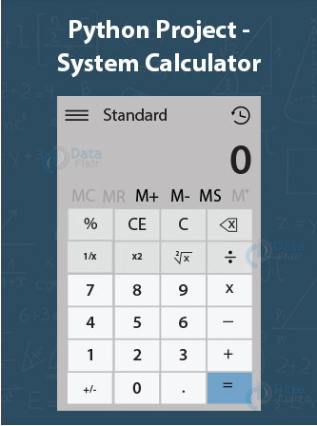

* Build a graphical user interface calculator using a library like Tkinter in which we build buttons to perform different operations and display results on the screen. You can further add functionalities for scientific calculations.
* This project will need functions, conditional statements and List. if you add a save feature then it will also use file to save the calculations.

This means we have to rely on Python build in data structures i.e. List, Sting, Dictionary etc. to manipulate data based on different operations.

So, you can pick any business problem of your interest where you can apply Data Structure concepts. Some examples business systems are:

1. Hangman Game
2. Random number guessing game
3. Currency Converter
4. Random Password generator
5. Alarm Tool

*[More Ideas 1](https://realpython.com/intermediate-python-project-ideas/)

*[More Ideas 2](https://data-flair.training/blogs/python-project-ideas/)

#### **Project Parts: Proposal, Milestone & Final Report**

**Submission**: We’ll be using KATIE for submission of all three parts of the final project. We’ll announce when submissions are open for each part. You should submit on KATIE as a group: that is, for each part, please make one submission for your entire project group and tag your team members.

#### **Evaluation**

I will not be disclosing the breakdown of the 32% that each project is worth amongst the different parts, but the proposal (presentation, report) and final (Proposal, Final report, Demo and Presentation) will combine the majority of the grade. Projects will be evaluated based on:

* + 1. The technical quality of the work. (i.e., Does the technical material make sense? Is Basic Data Structure used properly? Is the code neat and maintainable? Is it commented well so other can understand the code? Is the other modules and libraries used?)
    2. Significance. Is implementation of different business operations in software make sense?
    3. The novelty of the work. You need to ensure the originality of your work, project should not be a copied solely from any source. Even you are working on mirror/replication project, you should be in position to justify contribution.

In order to highlight these components, it is important you present a solid discussion regarding the learnings from the development of your method, and summarizing how your work uses the concepts we learned in our intro to Computer science class.

#### **Deliverables (Deadlines will be announced in class and on KATIE):**

#### **Project Proposals and presentation 27th April, 2020**

In project proposals, you will introduce your problem statement, data set required and general milestones you want to achieve during full phase of project. So, your project proposal will have following parts in it:

* + - 1. **Project title and team members:**  First you need state your project title with team member introductions.
      2. **Motivation:** What problem you are tackling? What application you can develop out of it?
      3. **Business operations:** You will discuss briefly what business operations you will cover or potential functionalities you want to add into proposed system?
      4. **Milestones:** You need to state some of your milestones with dates for your projects, this will help you to stay on routine.

You will submit your project proposal on KATIE and there will be mandatory Project Proposal Oral Presentation.

* + 1. **Project report, code and presentation 13th ,15th and 18th May, 2020**

You need to present for about 10 Minutes. There will be 5 minutes for Q & A session for each group.

You need to submit your final code/libraries and report **one day** before your presentation. Final report will have following components in it:

* + - 1. **Project Title and team members:** You need to write project name and team members name
      2. **Problem:** You need introduce your problem and briefly go through scenarios/operations/functions you targeted during your project
      3. **Model/Algorithms:** This portion will discuss which build in data structure or structures you used in your project and why you preferred it on others? How many functions you have used and are they returning /non returning?
      4. **What new thing you learned in python while doing this project:** You need to state what new module or structure you learned from python to do this project. Newer thing you learn and used more marks you will get.

You will submit your complete project documentation on KATIE and there will be mandatory Final Project Oral Presentation.

At any point if you struggle with your project and stuck, please do send me an email for online meeting time. All the best.